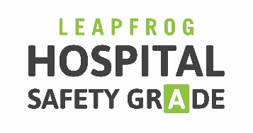

PURCHASER TOOLKIT
Posts for Internal Social Media Platforms (Enterprise Networks)

- Ntl nonprofit The Leapfrog Group grades hospitals on how safe they are for patients. Find out how your hospital scores on safety at www.hospitalsafetygrade.org
- Protect yourself & your loved ones, and check your hospital's Safety Grade www.hospitalsafetygrade.org #patientsafety @LeapfrogGroup
- #PatientSafety should always come first. Choose a safer hospital www.hospitalsafetygrade.org
- Be an empowered patient. Choose a safer hospital w/ www.hospitalsafetygrade.org
- Consumers need to know about safety & quality when making #healthcare decisions. Start now w/ www.hospitalsafetygrade.org
- Some ppl do more research on what car to buy than what hospital to go to. Change that now www.hospitalsafetygrade.org #patientsafety
- Does your hospital prevent infections & encourage handwashing? Find out www.hospitalsafetygrade.org #InfectionPrevention
- Does your hospital value #patientsafety by supporting strong #healthcare teams? Find out www.hospitalsafetygrade.org
- Does your hospital have protocols in place for preventing med errors? Find out www.hospitalsafetygrade.org

Tag Leapfrog’s channels:
- Twitter: @LeapfrogGroup
- Facebook: @TheLeapfrogGroup
- LinkedIn: @Leapfrog-Group

